Email Content:
Dear <sal><name of teacher>,

We are pleased to welcome your students to join us for the Science Chronicles writing competition.
Please refer to the brief information below. More details will be released on 26th May 2021.

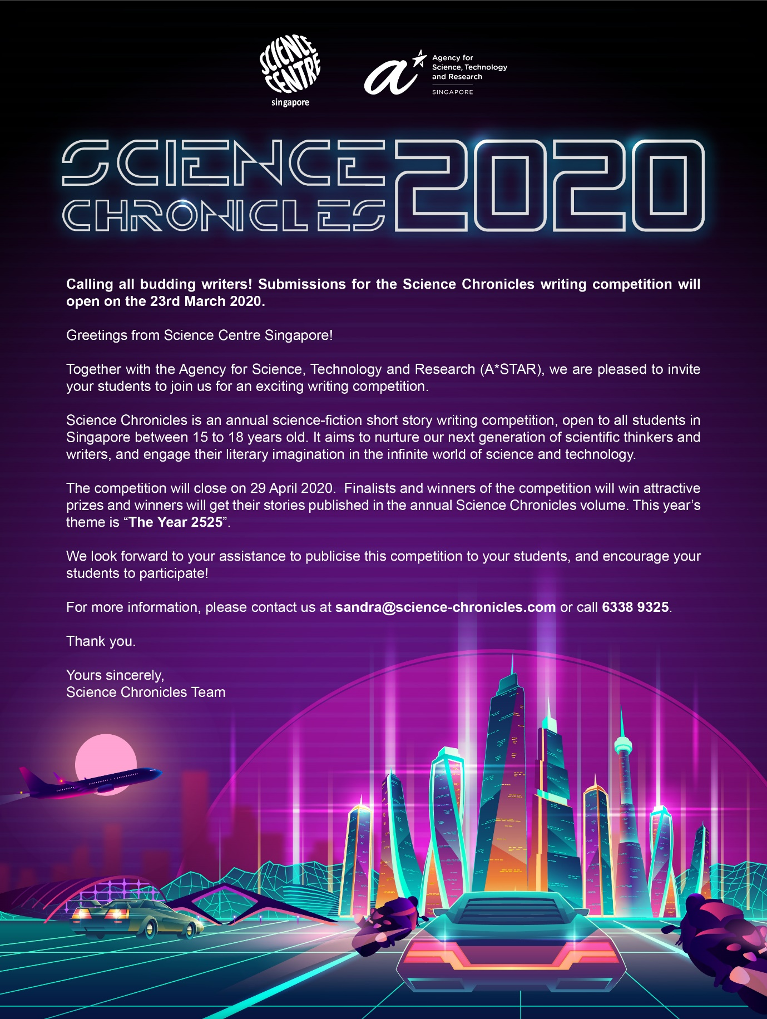
Content for eDM:

Calling all budding writers! Submissions for the Science Chronicles writing competition will be open on 26th May 2021.

Greetings from the Science Centre Singapore!

We are pleased to welcome your students to join us for an exciting writing competition.

Science Chronicles is an annual science-fiction short story writing competition, open to all students in Singapore between 15 to 18 years old. It aims to nurture our next generation of scientific thinkers and writers, and engage their literary imagination in the infinite world of science and technology.

The competition will close on 21st July 2021. Finalists and winners of the competition will win attractive prizes and winners will get their stories published in the annual Science Chronicles volume. This year’s theme is “Reimagine Our World”.

We look forward to your assistance to publicise this competition to your students, and encourage your students to participate!

For more information, please contact us at sandra@science-chronicles.com or call 6338 9325.

Thank you.

Yours sincerely,
Science Chronicles Team

