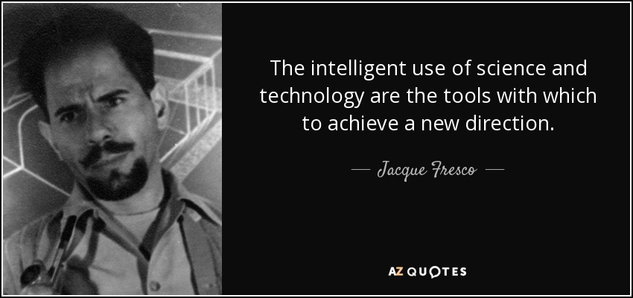
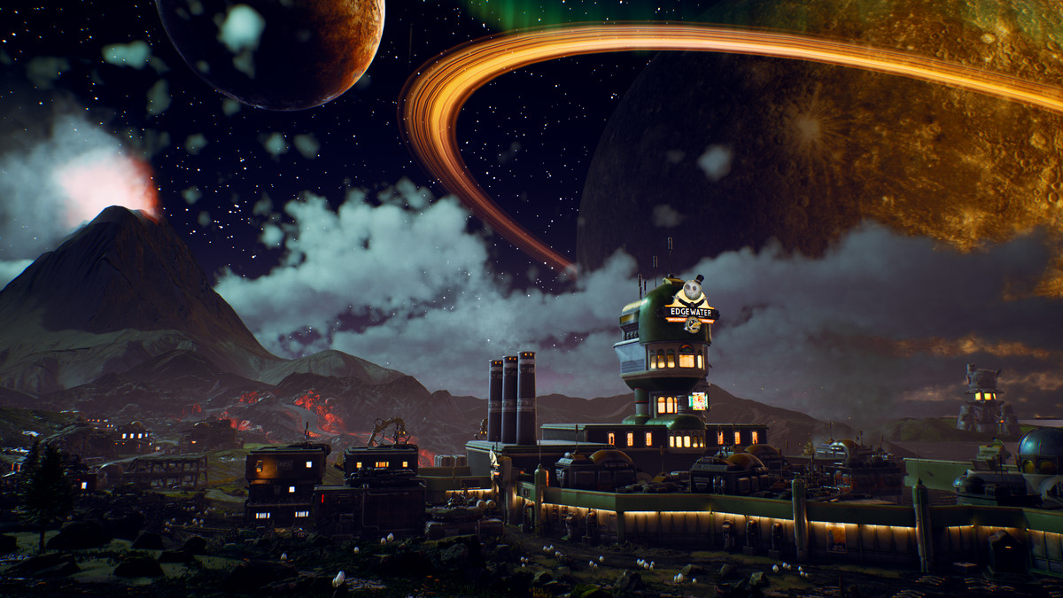
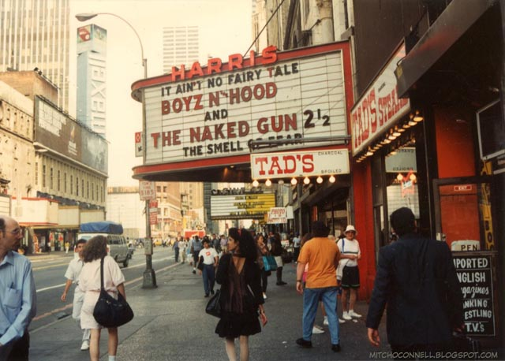
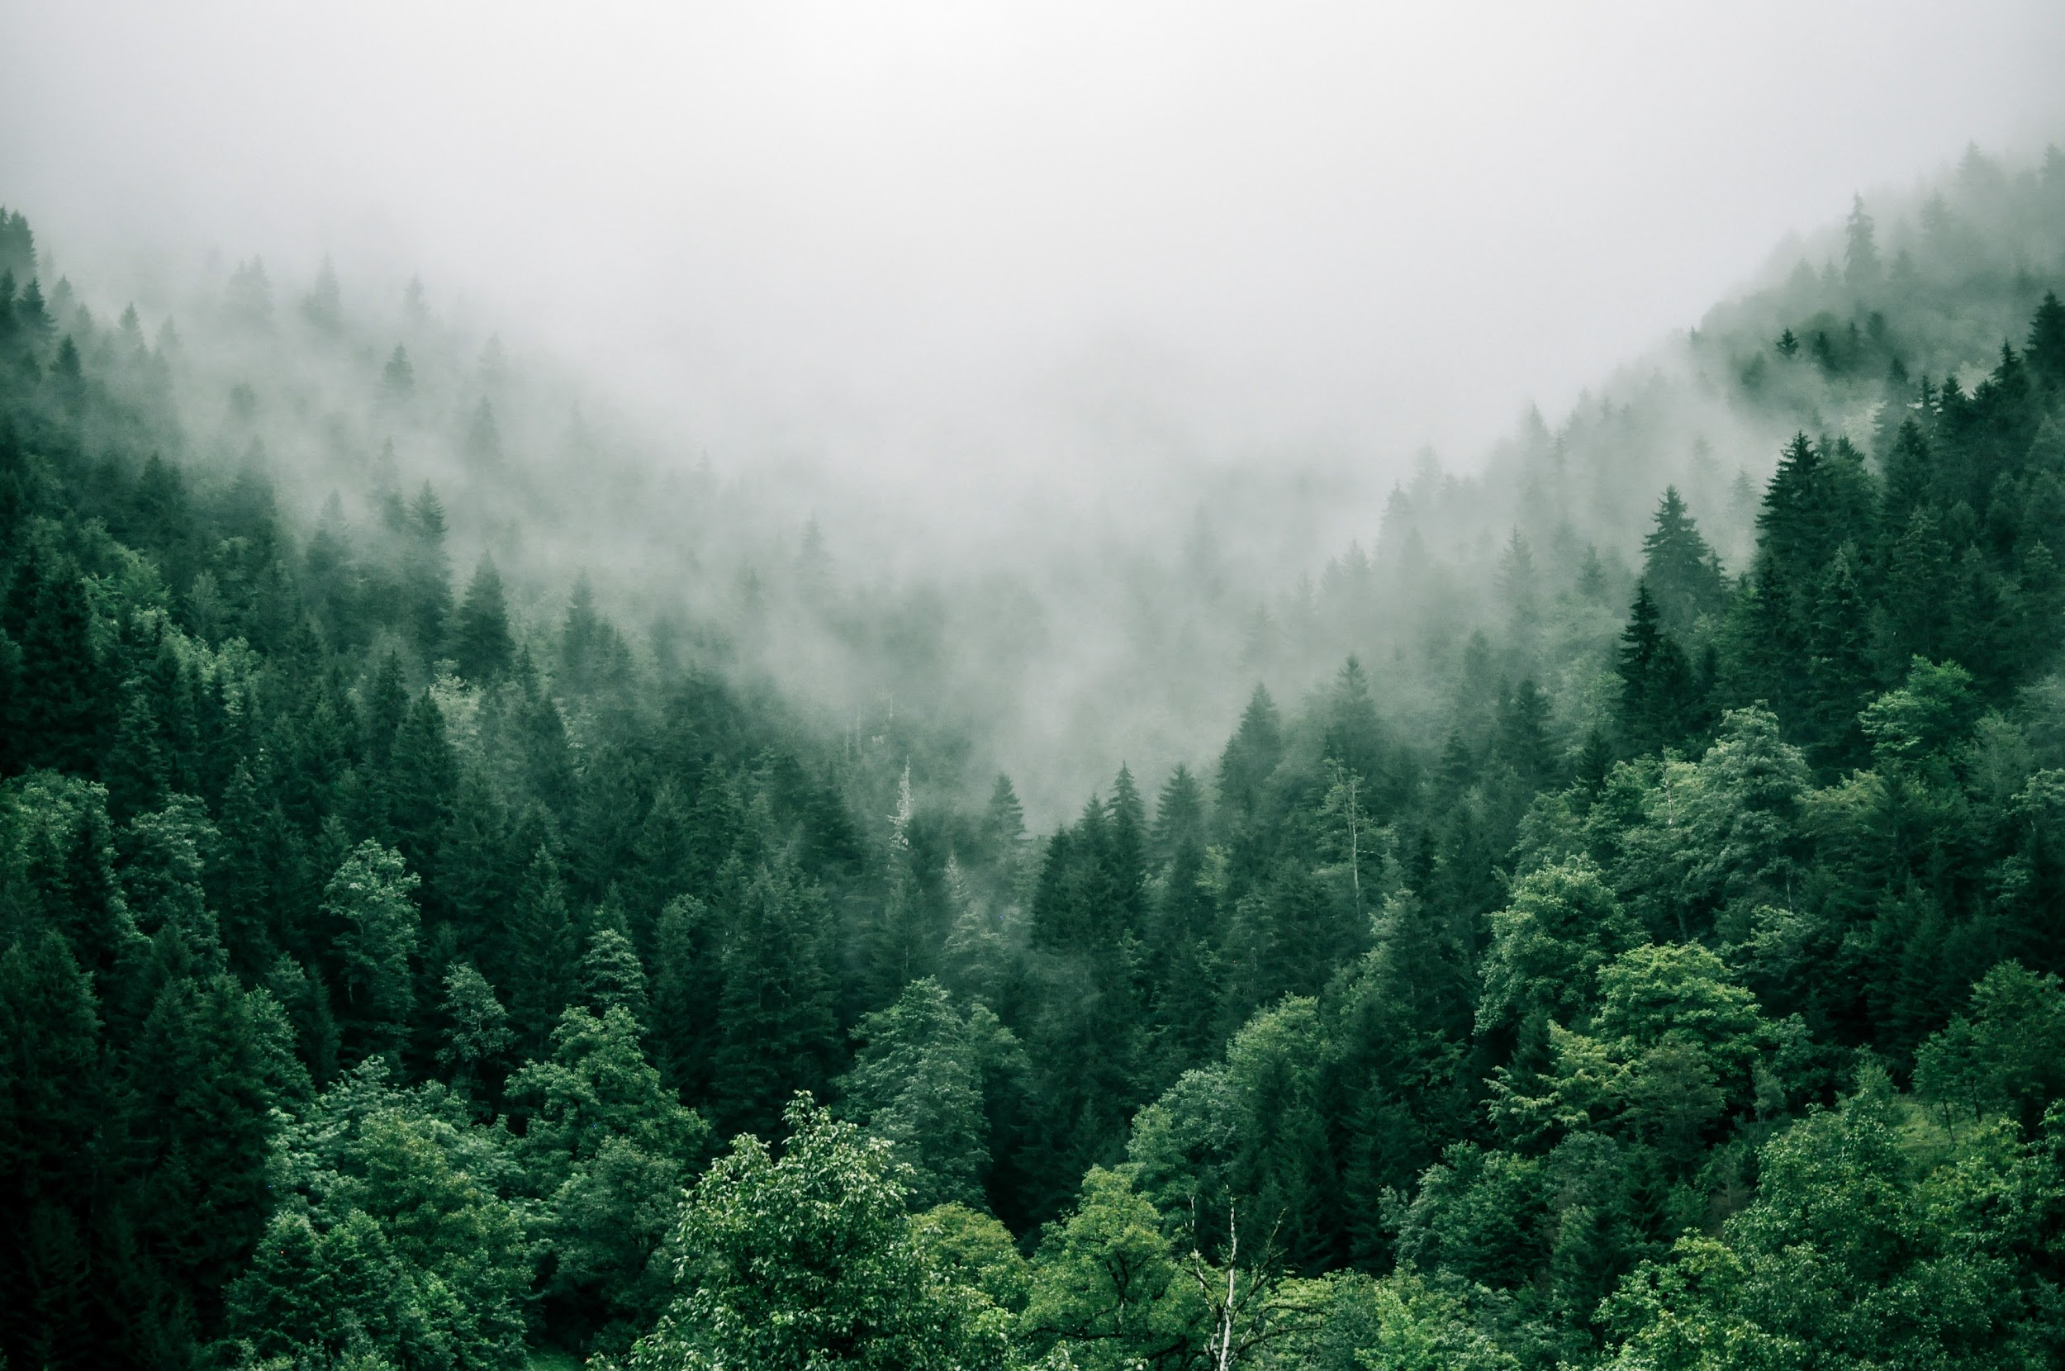

TRAVELLERS

In a world where different parts of the earth are divided into 3, the future, the backwards and the undiscovered. Different sectors have different ways of lifestyle, each relating to the names of the sectors.
The Future : Where all Science and Technology meet together.
The Backwards : Where time seems to move backwards… into the past.
The Unexplored : No one knows what’s out there, who’s out there. No one has been in or out, uncertainty learks at every corner of the area, waiting to be explored.
In this world we call earth, every person is born into a sector and lives there for most of their life till they turn 21. Once the age is right, they are given two choices to move or stay in their sector. To them, the unknown is better to stay unknown, which means the unexplored stays unexplored. It is forbidden to cross a sector without getting approval from the governments, which is exceptionally difficult, due to both governments' differences in leading their citizens. As a result, a huge crack between both sectors is created, many people who moved to a desired sector, usually stay there for the rest of their lives. Choosing a sector is thus, made the most important decision in a person’s life.
‘I hate this, every single time I do this exact thing, it just doesn't work’’, Rino screamed at the machine, kicking it multiple times. Rino Cainton, a 18 year old boy, living in the future sector, studying at an engineering school, under environmental protection. Rino was working on a school project, where the students have to try building a product suitable for the environment through virtual reality. However, unluckily for him, his virtual reality set was not working, making his project glitch and restart. Muffled laughs and coughs were heard from the entire class as Rino continued to struggle. Seeing this, the teacher quickened his steps to reach him and assist, he told Rino that the school would send him a new set of virtual reality right after school. Rino's face emerged with a bright grin as he thought of ways to ‘decorate’ the drone as it flies over to his house and drops off his package. Rino’s grin immediately drop after the teacher commented ‘I better see the drone in the same condition it was sent to you in, understand? ’. Rino peeked at the teacher's stern gaze, and winked. Rino was always known as the goofy, kinda popular kid in class. As always, the teacher rolled his eyes and continued to walk around.
In another class next door, they were studying medical and biomedical engineering . Their lesson was a little different. In a dark room, decorated like an operation table, showed a 3D hologram of a body on it. For that lesson, the students were tasked with learning how an operation works. The students are to walk around the classroom, work together to check if the steps of the professor performing were correct. As the professor touched the hologram, it reacted as if an actual surgery, the only difference would be the presence of a physical body. ‘Stop! Go any further and you're gonna kill that person’ , a strong female voice was heard across the room. The voice was traced back to a girl with black hair, green pupils and a white overcoat. She was known as the star student, Rosaline Marie. The professor glanced upward towards the voice and smiled, her wrinkles near her eyes were more obvious than ever. ‘Good job, you caught it right in time. Everyone else should use her as an example’ , the professor proudly announced to the room. Loud claps were heard from the room in an instant.
A few hours passed by, and both Rino and Rosaline ended their classes and were on the way back to their dorms. In their sector, there was barely any walking as safe, convenient and efficient electric scooters were invented. There were almost no wheels seen on the road as cars, scooters, and public transport used the ‘bullet train’ technology from another famous inventor. It works on the principle of magnetic repulsion between the transportation and the track, this also helped in the economy of this sector as due to the fact that the transportation were ‘floating’ , it eliminated friction allowing the transportation to travel at high speeds. This was a great success as when it started, there was a significant increase in the economy as it reduced time to travel around. Rino hopped on his scooter and zoomed off, followed by Rosaline. They live in the same dorm, same level, next to each other but the surprising thing was, they were strangers. However across the walls separating them, they were pretty similar, looking for the same thing, looking for something that belonged to them.
Rosaline opened her door through eye recognition as the future sector no longer made locks and keys. She kicked off her shoes and immediately jumped onto her bed. In the dorm, every student is provided a self - cleaning vacuum, not only vacuum but sweeps, mops, pick up stuff and tidy the place up. As the vacuum has a sensor that can detect movements in the house so it could tell if the owner is home, if there are objects on the floor or obstacles around them. Rosaline’s vacuum sensed her presence and the shoes lying on the floor. It moves slowly avoiding all the obstacles like tables and chairs, slowly making its way to the shoes. The vacuum picked up the shoes and continued its way to the show rack, placing the shoe on the bottom layer. Rosaline was thoroughly tired as she was working all night before, her watch had alerted her earlier that her energy was deteriorating quickly, that she needed to rest. Once she felt her bed under her, she fell asleep instantly, the room was pin drop silence with occasionally lightly snoring heard. Rosaline was always a girl who sought after adventure, from when she was born, she dreamed of the outside world, a world that has no specific way of life, a way that fits her. However as she is only 18, she had to wait 3 more years to choose, she still had no idea of the most important life decision. One thing she was sure of was that she did not want to stay in this sector. She detested the way the future sector was governed. Due to how advanced technology is in this sector, the government was not scared of citizens, therefore ignoring most citizens' pleas for more freedom. As she learned in her previous schools, the future sector was almost like a communist state, something that went against her belief for freedom and choice.
As Rosaline slept, Rino on the other hand was exercising in his dorm. Sweat beads formed on his forehead, dripping down his face, perspiring heavily. His muscles bulged every time he lifted up the weights, his abs engaged and his 8 pack was like it was sculpted by clay. Rino had music playing while he exercised, to him, exercising was a way for him to vent his frustration, he was flashing back to the phone call he had with his parents. ‘There is only 3 years left until the decision, have you decided yet?’ Rino’s mum enquired. Rino sighed heavily as he had been asked this question constantly, he just couldn't seem to find his answer, he longed for something more than these four walls separating the sectors. Rino replied annoyed ‘I do not know. I am confused. How am I supposed to decide such an important life decision and not regret it in the future’. As he felt the last amount of energy drained out of him, he dropped his weights not noticing the loud ‘thud’ sound echoing through the wall. Rosaline awoke with a startle upon hearing the thud sound, she shot up and glanced around the room for any indication that any of her furniture dropped. Another thud sound was heard, but this time she noticed that the sound came from the dorm next door.
Her curiosity got the best of her, she quickly got up and left the house. Rosaline walked out and to her neighbors door. There was no need to knock as the doors would sense people in front of it and send notifications to the owners. Rino was disrupted from his thinking as his wrist bracelet started blinking and vibrating. With one flick of the wrist, there was a hologram phone projected on the palm of his hand. He pressed his notification and made his way to the door. Rosaline was contemplating whether to wait there for the door to open or make her way back to her room. Just as she decided to leave, the door flung open and there stood Rino perspiring from his workout. ‘ So… Are you going to keep staring at my amazingly hot body? Rosaline flushed at his words, her brain couldn’t comprehend what was happening. She eventually came out of her vegetative state and found Rino leaning on the door and staring at her with curiosity. This is because in the future sector, due to the advancement of technology, many people started making friends from online to real life. It was surprising to meet strangers face to face, without any form of prior contact. Their first meeting etched in their brains with, looking back at this day no one would expect them to get so close, almost to the extent of even more than close friends.

A few weeks passed as they got closer to each other, they started to learn more about each other. They would share their deep conversations with each other almost every night. Thus, they found out that in their different world, they were actually so similar, from the way they dressed and what they like to what they wanted in the future. Which was ironic as both of them had no clue they only wanted somewhere they felt like they belonged but it obviously wasn't here. ‘You know what, I’m sick and tired of staying here, not as in like this dorm but this place. This sector. I want to feel like I belong somewhere, that I have a freedom of choice.’ Rino exclaimed while pacing around the room. Rosaline looked at him into his eyes, her eyes held a mischievous glint. She thought for a few seconds, while maintaining eye contact and replied ‘I know, I know, I hate the fact that we have no freedom, and definitely not a place that feels right. But I have this crazy idea, like crazy, we could escape and check out the backward sector? It might be what we are looking for’ Upon hearing this Rino eyes widened in disbelief, but the more he thought about it the more his face broke into a wide grin. Rino thought to himself, there wasn’t really anything wrong with this idea, they just needed a plan, and it had to be a good one. Rino sat down on his bed, and stared at his ceilings. His room lights changed to blue as his bed had a sensor that could feel the users mood, changing the room surrounding to fit the users need.
Rosaline watched as Rino’s face relaxed and waited anxiously for his reply. Her heart beat increased as indicated on her watch, it sent her multiple alerts to warn her and if needed she could call the ambulance with one press of a button. Rino upon noticing her alerts, called out her name. Rosaline snapped back and walked over to Rino’s bed and sat down. She was glad with what she heard next, Rino looked at her and said, let’s do it, no regrets in this life right? They spend the whole night discussing what the plan is and eventually fall asleep on his bed on top of each other. They decided on the annual electricity check up hour to slip past the border. That hour is when the whole sector shuts down electricity to check all the working conditions, it happens once annually. Luckily for Rino and Rosaline they made it just in time to find an opportunity to slip out. The checkup was happening that night, so while waiting for the time to come, they both went back to their dorms and packed for the trip.
When the time came, they met up 5 minute before the shutdown of electricity, they met near the border making sure they were not seen. The whole city lights shut down, no cars, no phones, nothing it was like the whole city shut down. However no one was panicking as they knew it would only last for one hour. To citizens in the future sector, one hour is only one hour but to Rino and Rosaline it meant the whole world to them. It was their only chance, if they missed it they have to wait till next year, if they were caught they would be jailed and there wouldn't even be another chance for them. Before this, Rino went out and purchased night goggles as they were not going to take any chances of being caught. He passed their set of contact lenses night goggles to Rosaline and both of them placed it in their eyes. After confirming that they both were okay to continue, they crouched down and tiptoed as near the border as they could get. The border was made up of a type of fence, it is not only electrical but also when touched emits a chemical that sticks to your body for several days. The chemical is not easily removable as it cannot be washed off. Keeping this in mind, Rino had already thought of an idea beforehand which was to cover the electric fence with a material that can cover the sensors on the fence. This will not only block out the electric shock emitted by also the chemical produced by the fence when touched.
After placing the piece of cloth over a part of the fence, they took turns climbing it. As one of them climbs the fence, another one watches out for guards or any other sensors. Behind the fence was another thick wall made of a type of concrete. This was the harder part of escaping as the walls were filled with cameras at every corner. Nevertheless, Rosaline had already gotten the floor plan for the cameras and planned out the safest option. The safest option also had its dangers so Rosaline made sure to run through the plan with Rino multiple times. As Rosaline led the way through the path she memorized for the millionth time, she made sure to turn around to check if Rino was following. When Rino and Rosaline started this crazy idea, it was an unspoken agreement that they were in this together, if one falls both fall, if one stands, both will stand. As Rosaline got nearer and nearer to the other side of the border, the siren to alert that someone was escaping sounded. It was loud and did what it was supposed to do, alarming the guards to start checking and blocking exits. Upon hearing this, Rosaline had to think fast and run out of this area immediately. Rino acted faster, he pulled her along the path he had to hear for millions of times but in his mind he was thankful for.
Rino remembered his bag contained a puppet that could deter the sensors placed around, it would disrupt the signal and act as a distraction when they ran in their direction. He quickly pulled it out of his bag and placed it on the ground. Rosaline watched his every movement and understood what he planned to do. Both of them started running as fast as they could, without turning back as they could feel each other's presence running next to each other. Although they were a nervous wreck, anxiousness hitting high levels, in their minds they longed for this feeling of exhilaration, the sense of freedom, the feeling of the wind brushing past their face as they ran. They ran as their life depended on it, literally. Everything was happening around them, the loud blaring noise, the shouting of orders through the speakers, the loud footsteps heard. But to Rino and Rosaline, it was just the background, they were the authors of their own stories. From now onwards, they write their own future with no one stopping them. To them, who cares about the uncertainty, who cares about the unknown, those few words only exist for them to be explored.
The next day, the news was broadcasted all over the city and it didn't stop there as the backward sector had published it on its newspaper also. As everyone was reading the reports and news of them, they only had one question that popped up in their head, where did they go? They were never heard of after this, unknown to them was that many people their age had already been inspired by their actions. As they are far out in the world somewhere, taking their steps of determination one by one, they had a whole group of people following them step by step. To the whole group, the uncertainty was their comfort.
(2899 words)

